Power Bi Report Screeenshot

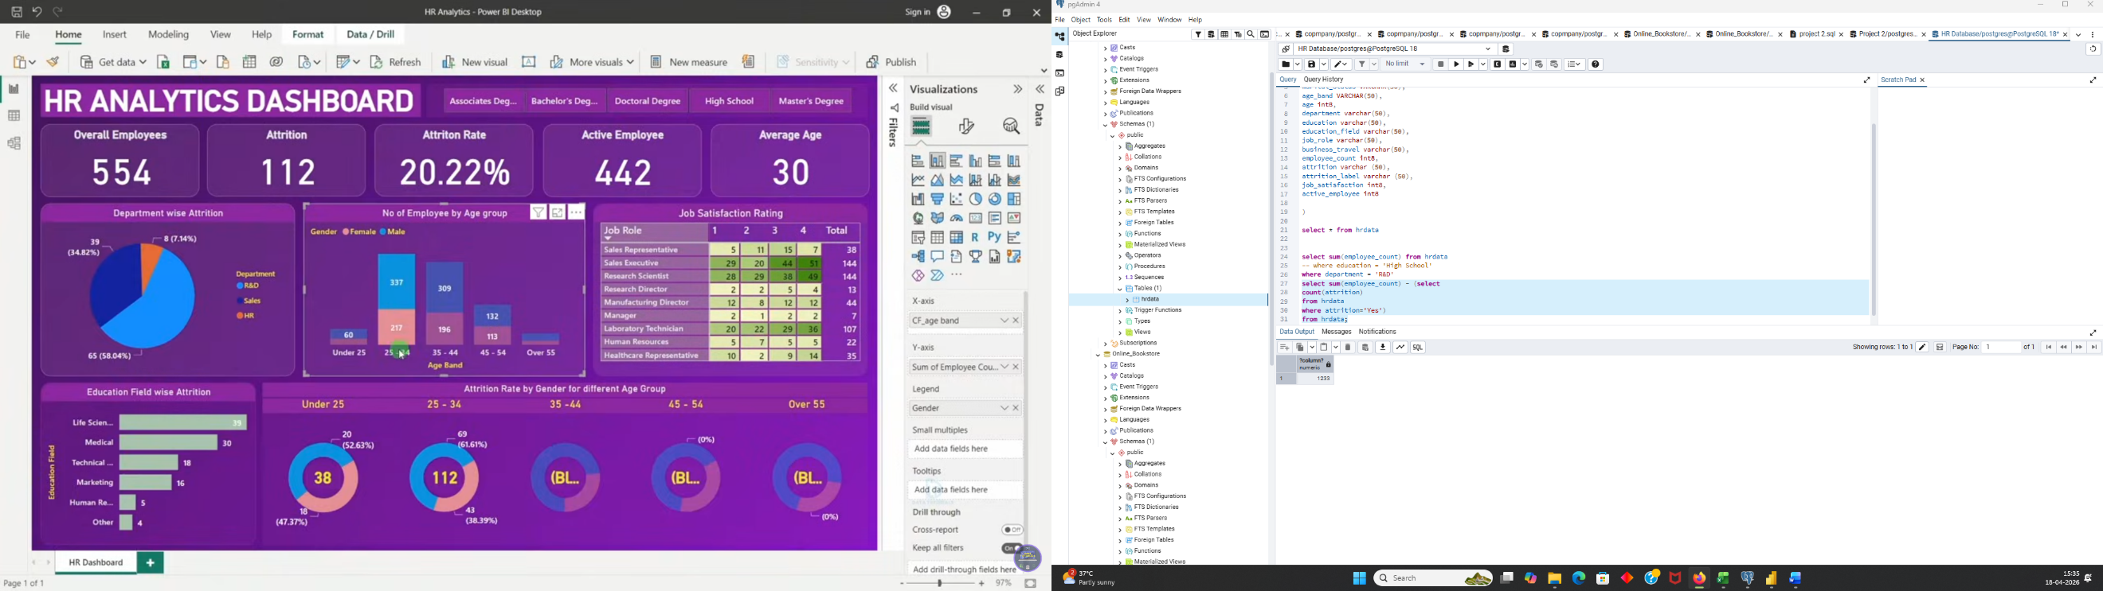
TEST DOCUMENT

Client Name | Data Tutorials
Report Name | HR Analytics Dashboard
Developer Name
Tester Name
Project Manager
Development Tool | Power BI

Test No. | Sheet Name | Query | Test Result | QA Remark
1 | KPI- Employee Count | select sum(employee_count) as Employee_Count from hrdata; | Pass | Exact match
2 | KPI- Attrition Count | select count(attrition) from hrdata where attrition='Yes'; | Pass | Exact match
3 | KPI- Attrition Rate | select  round (((select count(attrition) from hrdata where attrition='Yes')/  sum(employee_count)) * 100,2)  from hrdata; | Pass | Exact match
4 | KPI- Active Employee | select sum(hr.employee_count) - (select count(attrition) from hrdata where attrition='Yes') from hrdata; | Pass | Exact match
5 | KPI- Average Age | select round(avg(age),0) from hrdata; | Pass | Exact match
6 | Attrition by Gender | select gender, count(attrition) as attrition_count from hrdata  where attrition='Yes'  group by gender  order by count(attrition) desc; | Pass | Exact match
7 | Department wise Attrition | select department, count(attrition), round((cast (count(attrition) as numeric) /  (select count(attrition) from hrdata where attrition= 'Yes')) * 100, 2) as pct from hrdata  where attrition='Yes'  group by department  order by count(attrition) desc; | Pass | Exact match
8 | No of Employee by Age Group | select age_band, gender, sum(employee_count) from hrdata  group by age_band, gender  order by age_band, gender desc | Pass | Exact match
9 | Education Field wise Attrition | select education_field, count(attrition) as attrition_count from hrdata  where attrition='Yes'  group by education_field  order by count(attrition) desc; | Pass | Exact match
10 | Attrition Rate by Gender for different Age group | select age_band, gender, count(attrition) as attrition,  round((cast(count(attrition) as numeric) / (select count(attrition) from hrdata where attrition = 'Yes')) * 100,2) as pct  from hrdata  where attrition = 'Yes'  group by age_band, gender  order by age_band desc; | Pass | Exact match
11 | Job Satisfaction Rating | SELECT * FROM  crosstab('SELECT job_role, job_satisfaction, sum(employee_count)  FROM hrdata  GROUP BY job_role, job_satisfaction  ORDER BY job_role, job_satisfaction'  ) AS ct(job_role varchar(50), one numeric, two numeric, three numeric, four numeric)  ORDER BY job_role; | Pass | Exact match

Test Result:
Total Tests | 11
Pass | 11
Fail | 00
Blocked | 00
Not Executed | 00

